**Sprint 1 Plan**

**PantryPal**

**July 3, 2023 - July 9, 2023**

**Revision: 1.0.0**

**Revision date: July 3, 2023**

**Goal:** Create a minimal web app that is able to take a user input and parse out recipes based off of the ingredients given

**User stories:**

* As a user, I want a user interface to input my ingredients. **Total 12** 
  + Design Mockups: UI/UX designer will create mockups of our application. Although Streamlit provides basic layouts, having a clear idea will guide our development. **(2)**
  + Setup Streamlit Environment: Set up a new Streamlit project, establish the necessary Python environment, and ensure Streamlit runs correctly. **(4)**
  + Create Input Form: Build a form using Streamlit's capabilities where users can input the ingredients they have. **(2)**
  + Make API Request: Write a function to take the user's input, make a GET request to our Flask API, and receive the recipe recommendations. **(4)**
* As a user, I want a variety of recipes based on the ingredients I listed **Total: 8**
  + Identify Target Websites: Research and identify the websites we want to scrape for our recipes.**(2)**
  + Setup Scraping Environment: Set up a Python environment suitable for web scraping, including installing necessary libraries such as BeautifulSoup and requests.**(2)**
  + Design Scraping Logic: create a function or script that fetches a webpage and extracts the necessary data (e.g., recipe names and their ingredients). Work with ML team to see what data schema to use **(2)**
  + Initial Scraping: Perform an initial scrape to see if we can successfully extract the data we need. **(2)**
* As a user, I want to receive recipes recommendations without having to build the ml model myself **Total 6**
  + Setup Flask Environment: Set up a new Flask project with the necessary Python environment, install necessary libraries, and ensure Flask runs correctly. **(2)**
  + Design API Structure: Decide on the API's structure. Define the routes and the data each route will receive and return. **(2)**
  + Implement 'recipes' Endpoint: Develop a GET endpoint that accepts a list of ingredients as input and returns placeholder data. **(2)**
* As a user, I want to receive relevant recipe recommendations that can be made with the current ingredients that I have. **Total 11**
  + Define csv table layout: to figure out what preprocessing needs to be done between scraping and creating the model **(2)**
  + Preprocess the data for model: lemmatize words, get rid of unnecessary adjectives, remove stop words. (**2)**
  + Use word2vec embeddings to create a model: find which ingredients best match each other. (**3)**
  + Use KNN: to find which are the n most relevant recipes **(2)**
  + Use tf-idf: to find the most significant ingredients in a recipe or rare ingredients **(2)**

**Team roles:**

* **Sayak:** Product Owner, Frontend Developer
* **Aaron:** Scrum Master, Backend Developer
* **Yera:** Frontend Developer
* **Hisham:** Frontend Developer
* **Raghavendra:** ML engineer
* **Zhengheng:** ML engineer

**Initial task assignment:**

* **Sayak:** As a user, I want a variety of recipes based on the ingredients I listed, identify target websites
* **Aaron:** As a user, I want to receive recipes recommendations without having to build the ml model myself, setup flask environment
* **Yera:** As a user, I want a user interface to input my ingredients, design mockups
* **Hisham:** As a user, I want a user interface to input my ingredients, design mockups
* **Raghavendra:** As a user, I want to receive relevant recipe recommendations that can be made with the current ingredients that I have, define csv table layout
* **Zhengheng:** As a user, I want to receive relevant recipe recommendations that can be made with the current ingredients that I have, define csv table layout

**Initial Scrum Board:**

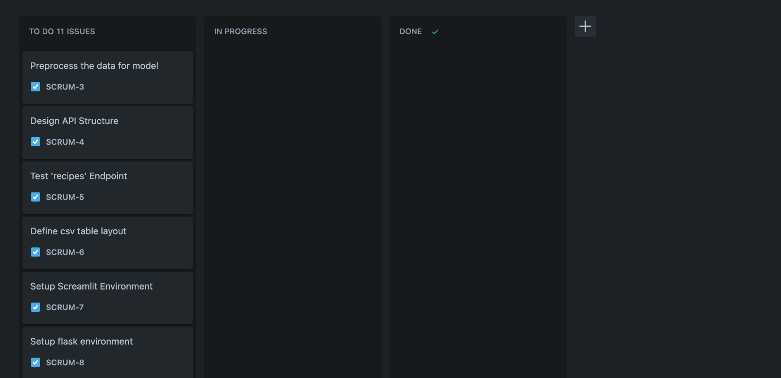

**Scrum Times:**

Mondays: 6-7pm, Wednesdays: 5-6pm, Fridays: 5-6pm